Hands-On Exercises - Java Loops

**Setup Instructions:**

1. Use the workspace - “Assignments” - in Spring Tool Suite IDE that you have created in the previous exercises .
2. Create a new Java Project called “FullStackDay2”.
3. Create your classes in any package of your choosing.
4. Define your classes as given below for each assignment.

Assignment 01

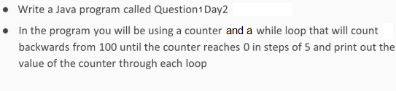

Output

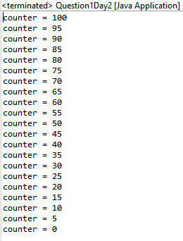

Assignment 02

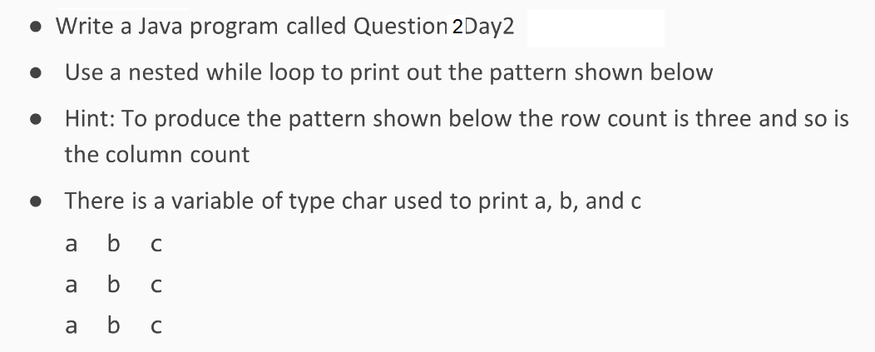

Output

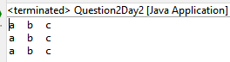

Assignment 03

**TestingIfAndIfElse.java**

**Create the folowing class to test If and Else Statements in java:**

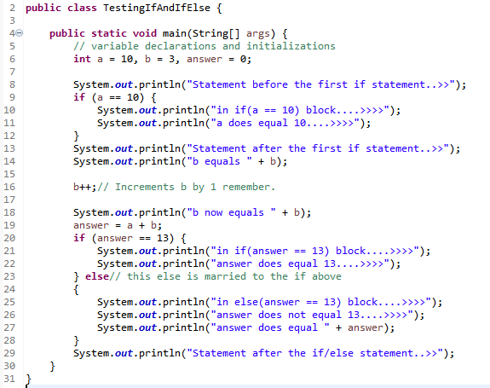

Output

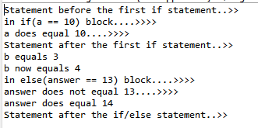

Assignment 04

**TestSwitchStatement.java**

**Create the folowing class to test Switch Statements in java:**

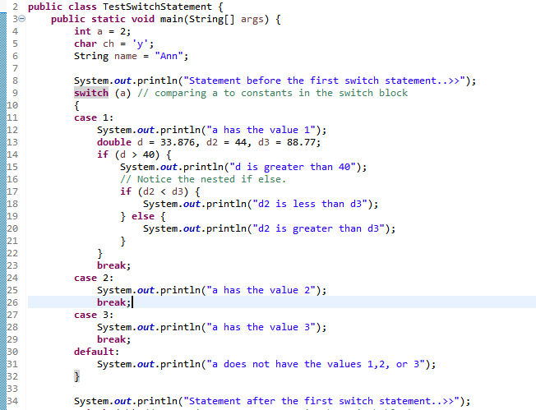

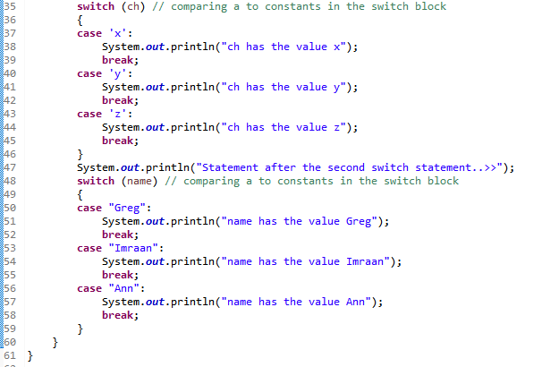

Output



